**The effects of large marine protected areas on industrial fishing effort**

**[hopefully something less dry]**

Conservation Letters: 3000 words, max 6 figures, max 40 references

TO DO:

* Review documentation of large MPAs. How many aimed to *reduce* fishing effort, and how many aimed to *maintain low effort?* See how many reach/fail that goal
* Review info on which nations sell fishing rights. Is this our best explanation of why effort is high in PIPA but low in Western EEZs?
  + DONE: see Havice 2013. The information on is publically accessible
* How many MPAs can we include if we go down to 30,000 km2 instead of 100,00 km2? Davies et al. 2017 uses this (equally arbitrary) cutoff

**ABSTRACT [150 words]:**

Large marine protected areas (LMPAs) of unprecedented size have recently been established in every ocean, yet their ability to meet conservation objectives is widely debated. Key areas of debate include uncertainty over the intensity of human impacts before and after MPA establishment, the effects of LMPAs on industrial fishing fleets, and nations’ abilities to adequately enforce fishing bans across vast, remote regions. We used a recent vessel tracking platform to quantify the response of industrial fishing effort to 6 LMPAs that were established since 2013. We find that 1) LMPAs successfully keep fishing effort low relative to surrounding regions, but 2) effort was already very low within LMPAs prior to designation. Taken together, our results suggest that LMPAs present conservation opportunities with relatively low political cost, though they typically do not *reduce* fishing effort as effort is already negligible in these regions.

**Figures**

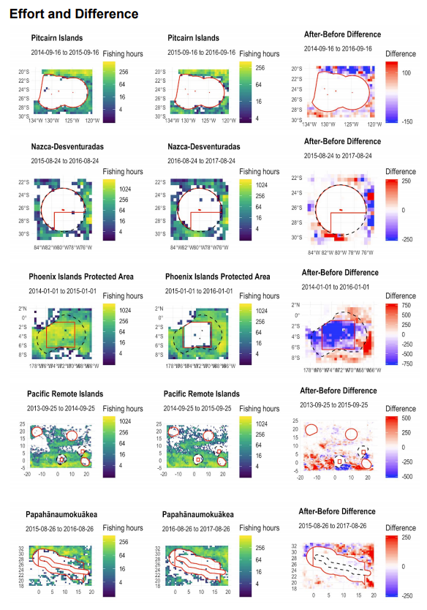Figure 1. Industrial fishing effort for one year before and after 6 large marine protected areas were established. Maps extend 1 degree beyond MPA boundaries (solid red) or EEZ boundaries (black dashes). Minimal fishing effort is seen in most large MPAs before or after their creation. High rates of fishing observed beyond the boundaries of most large MPAs indicate that industrial fishing vessels are respecting jurisdictional boundaries.

Figure 2. Monthly industrial fishing effort detected within large MPAs (black lines) and nearby Exclusive Economic Zones (EEZs) that permit fishing (colored lines). Virtually no fishing is detected within all MPAs after establishment while significant fishing is detected within nearby EEZs, suggesting that differences are due to regulations as opposed to remoteness. Minimal fishing effort is detected in most MPAs prior to establishment; only the Phoenix Islands Protected Area supported major fishing effort prior.

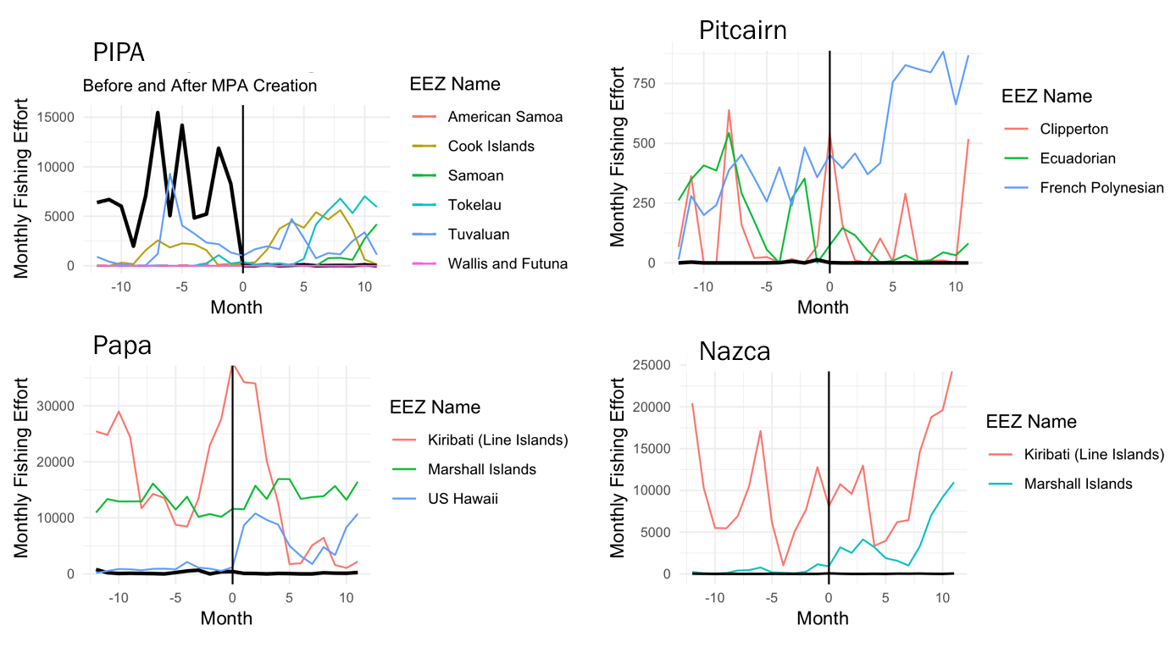

**INTRODUCTION**

More ocean area has been formally protected in the last XX years than in the preceding century.

References:

* Large MPAs are tough to enforce (De Santo 2013, Leenhardt et al. 2013, Wilhelm et al. 2014, Pala 2013, Jones and De Santo 2016)
* Remote zones have little human impacts so we should protect them (Nelson and Bradner 2010, Singleton and Roberts 2014, Toonen et al. 2013, Wilhelm et al. 2014, O’Leary 2018, Pala 2013). Gross 2018 alludes to low impacts in remote zones
* Remote zones have little impacts so we should *not* protect them (Devillers 2014, Magris and Pressey 2018)
* Large MPAs help *reduce* fishing (Pala 2013, Toonen et al. 2013)
* Large MPAs are in remote regions to buffer against future declines (O’Leary 2018)
* Contrary to common perception, large MPAs actually are subject to high levels of human impact (Davies et al. 2017). Large MPAs attract increases in fishing effort that lead to overfishing prior in between MPA announcement and legal creation (McDermott et al. 2018).
* Aichi Target 10 is to *minimize* impacts of vulnerable ecosystems. Most large MPAs established in recent years do not fulfill this goal as impacts are beneficially locked in at already-low levels, though they are not *reduced*.
  + Target 11 is to protect 20% - this one will be helped by large MPAs (Toonen et al. 2013)

To cite:

* O’Leary et al. 2018 – percent of ocean in MPAs, common criticisms of large MPAs
* Gross 2018 (Current Biology) news piece about the promise of new tech for monitoring MPAs, implies that Pitcairn has low effort because it’s remote so we can cite this
* Havice 2013 - good overview of Nauru Agreement, which describes the sale of fishing rights to other nations. Also mention US Tuna Treaty which is how US buys Pacific fishing rights (as opposed to selling them). This may partially explain patterns of low effort in developed/Western EEZs of the tropical Pacific.

**METHODS**

**Study area**

**REFERENCES**

**SUPPLEMENTARY MATERIALS**